**Project Design Phase-II**

**Data Flow Diagram & User Stories**

|  |  |
| --- | --- |
| Date | 14 october 2022 |
| Team ID | PNT2022TMID50823 |
| Project Name | Smart crop protection system for agriculture |
| Maximum Marks | 4 Marks |

**Data Flow Diagrams:**

A Data Flow Diagram (DFD) the farmer by a message while someone enter into the farm and we are used SD card module that helps to store a specified sound to fear the animalsThis project is smart crop protection system for protect the farm from animals as well as unknown person.

Example: DFD Level 0 (Industry Standard)

**Example:** [**(Simplified)**](https://developer.ibm.com/patterns/visualize-unstructured-text/)

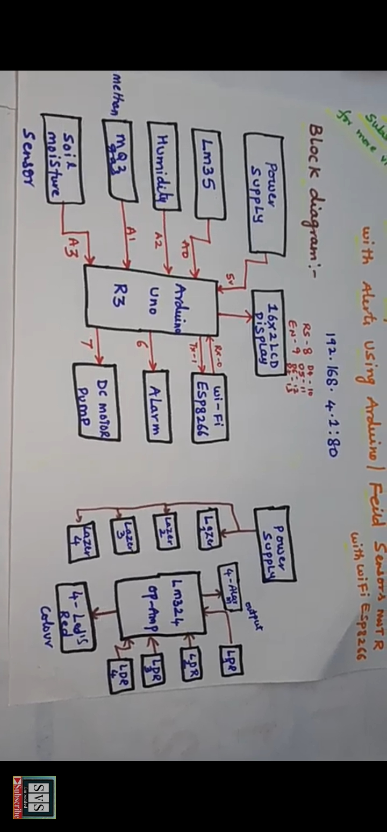

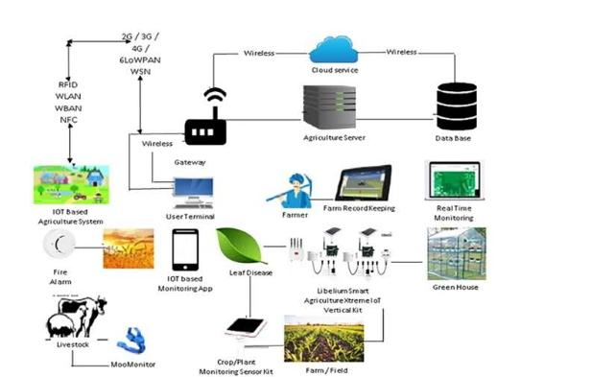

**User Stories**

Use the 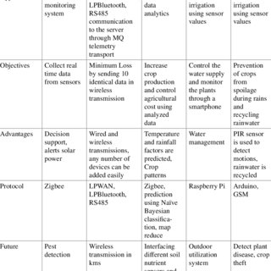below template to list all the user stories for the product.